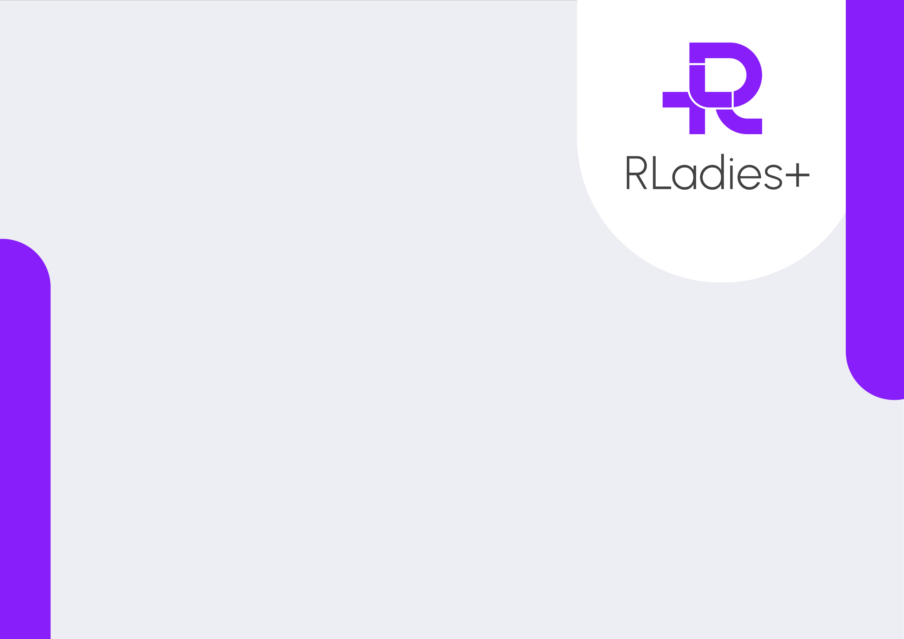
Rladies.org • info@rladies.org • regional chapter link or other links and logos here
This is awarded by the organisers of the workshop from the RLadies+ regional chapter Name Surname, Name Surname and Name Surname.
for completing the seminar called “Name of seminar or event” at this place or online on DD/MM/YYYY.

Certificate of Completion

Name Surname
Proudly presented to

